The following instructions are optional pre-work for the Actex webinar Python for Actuaries – Introduction to Data Analysis. Task I: Install Conda (pages 1 – 4) should be completed prior to completing Task II: Download the Data Files for Case Study II (page 5).

1. **Install Anaconda (Approximately 15 Minutes):**

Completely all four steps of this task should take approximately 15 minutes or less depending on the speed of your internet connection. Completion time also depends on the policies and procedures that your Information Technology department enforces for downloading open-source software programs. There is no fee for installing and using this software. The Anaconda open-source license is available from the Anaconda website for legal department review.

1. 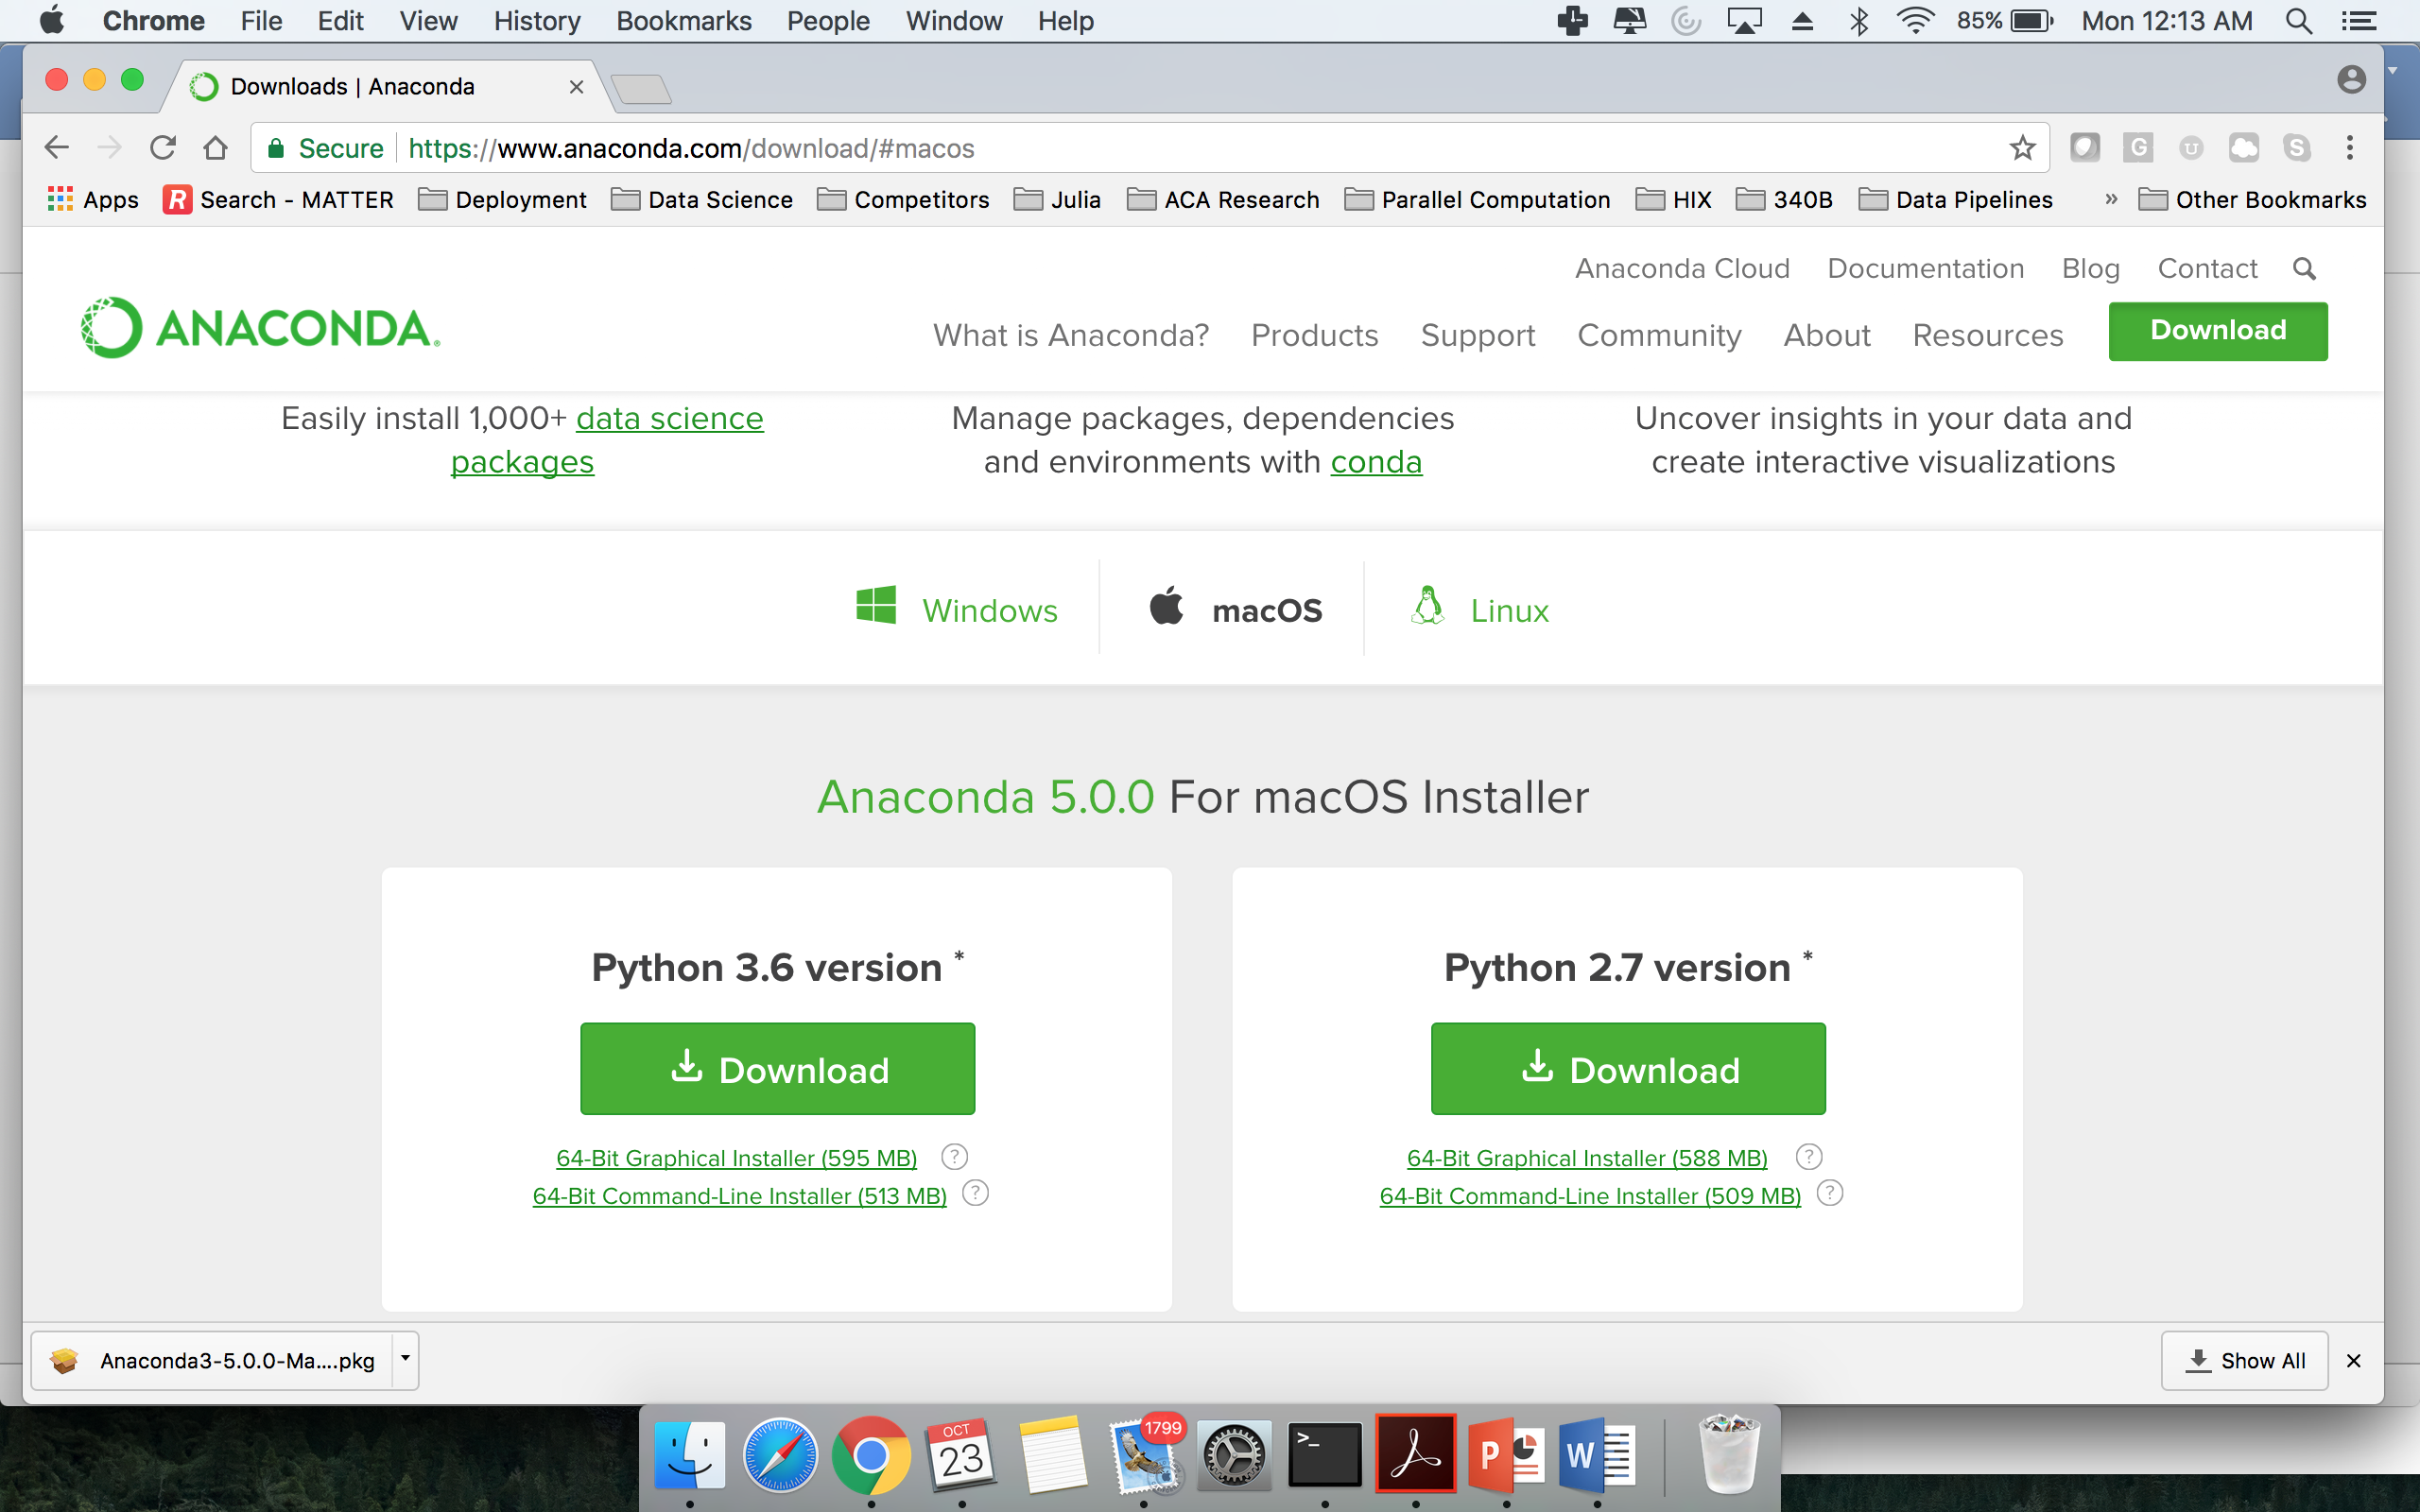Navigate to [www.anaconda.com/download/](http://www.anaconda.com/download/) to install the Python 3.6 version, 64-Bit Graphical Installer (535MB) version of Anaconda. Select the Windows version for Windows PC’s and the Mac version for Mac computers. The Mac version is shown below.
2. 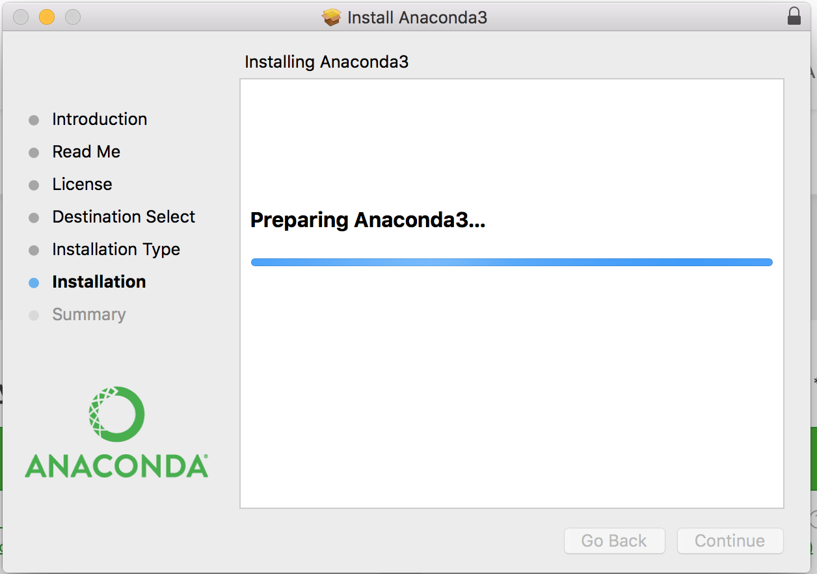Open the downloaded package and install Anaconda.
3. Verify download and launch Anaconda Navigator. A shortcut to Anaconda Navigator is provided after install for Windows users. The shortcut to Anaconda Navigator shows in the application folder for Mac users.

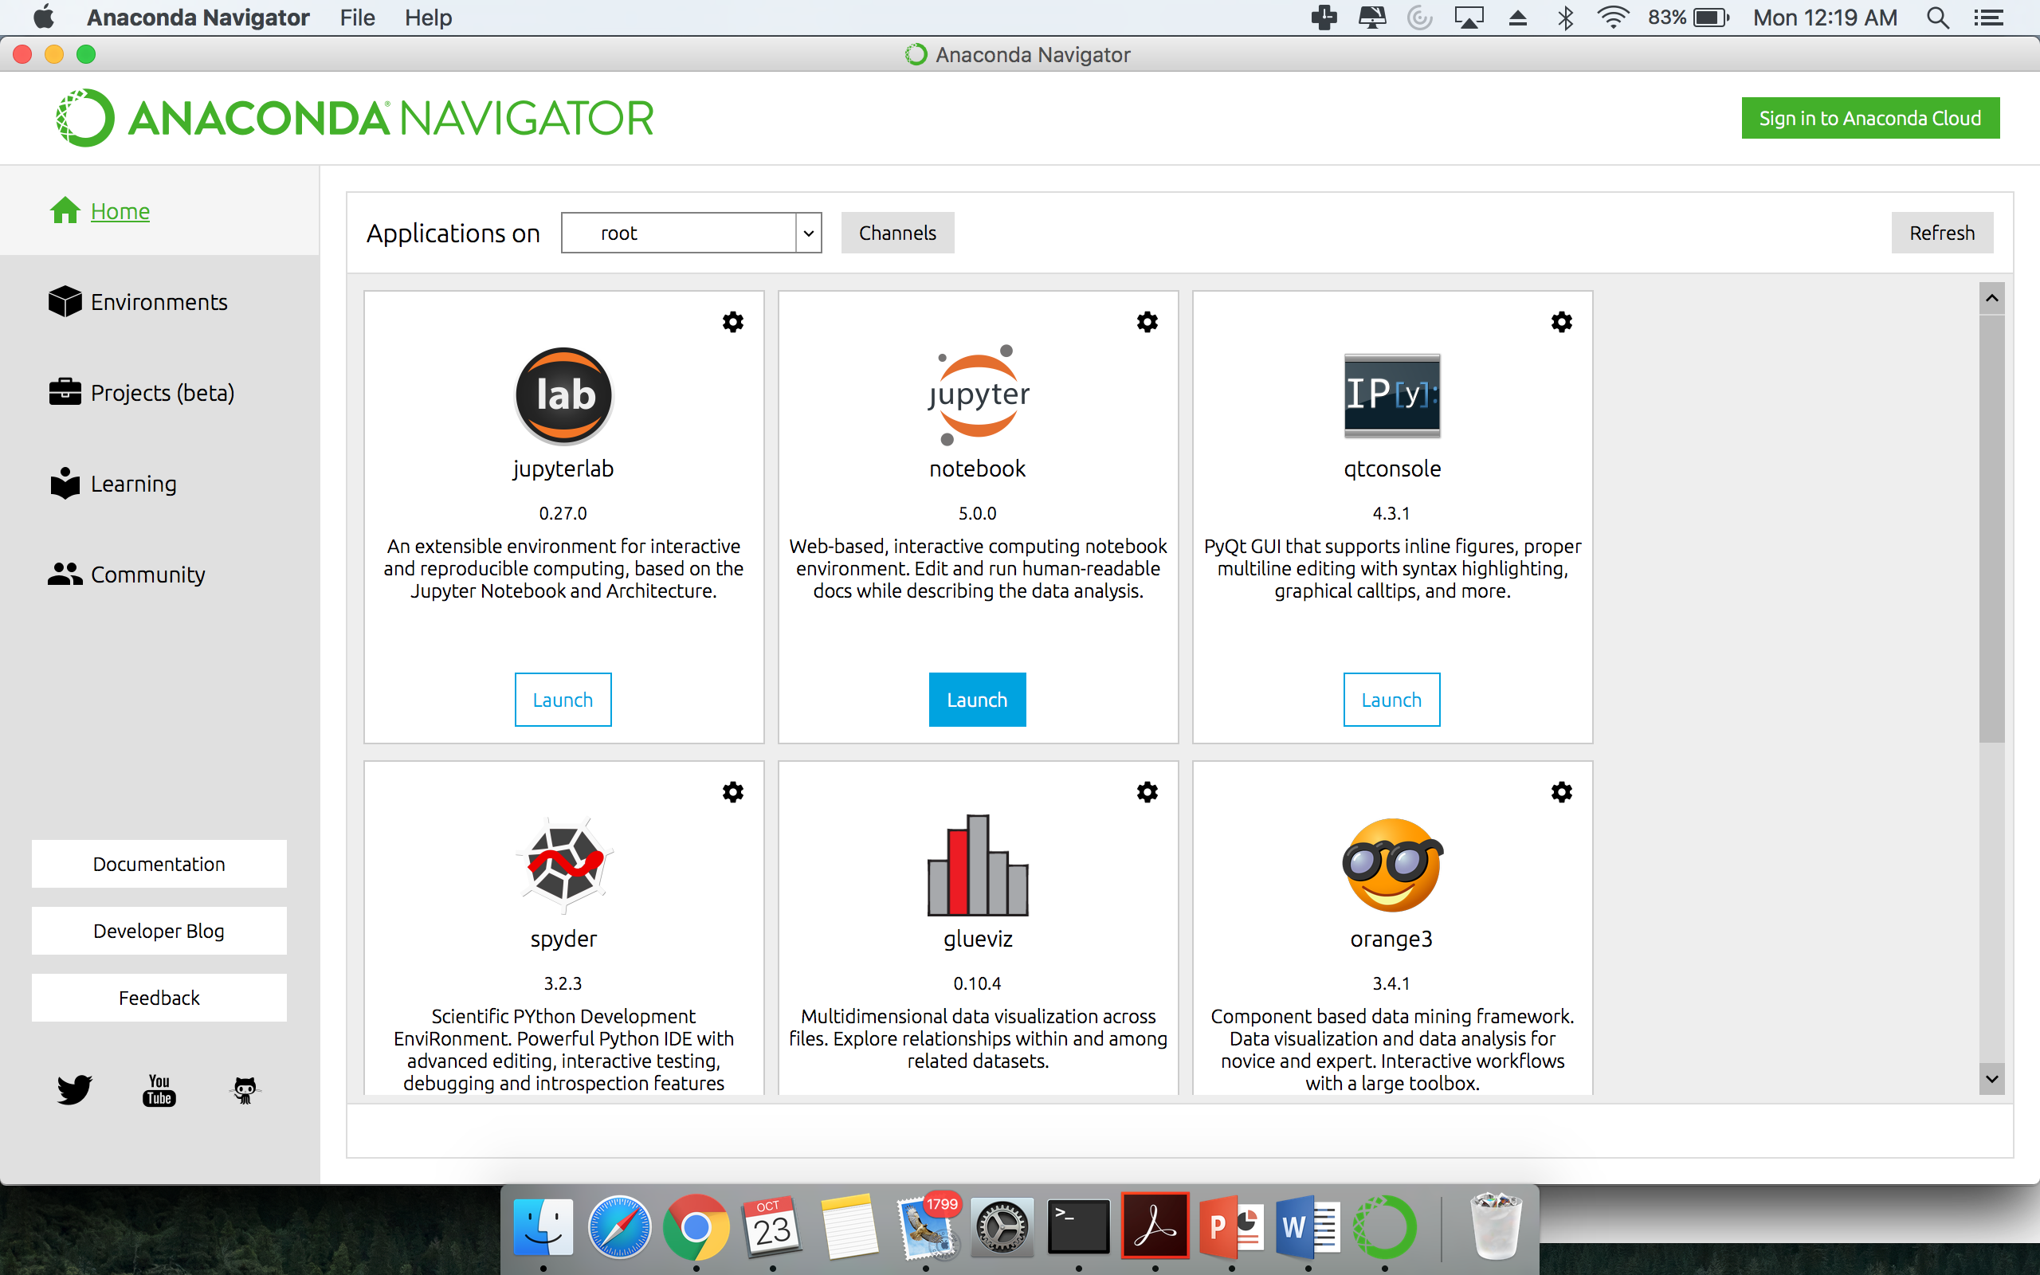

1. Launch the Jupyter notebook application to verify that the Anaconda was installed correctly. It should open a web browser listing the contents of the current user’s root directory.

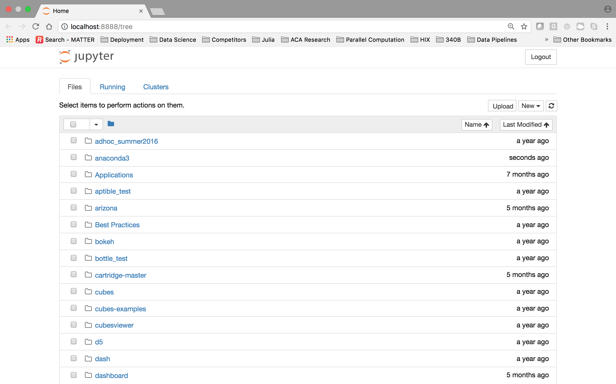

1. **Download the Data Files for Case Study II (Approximately 5 minutes):**
2. 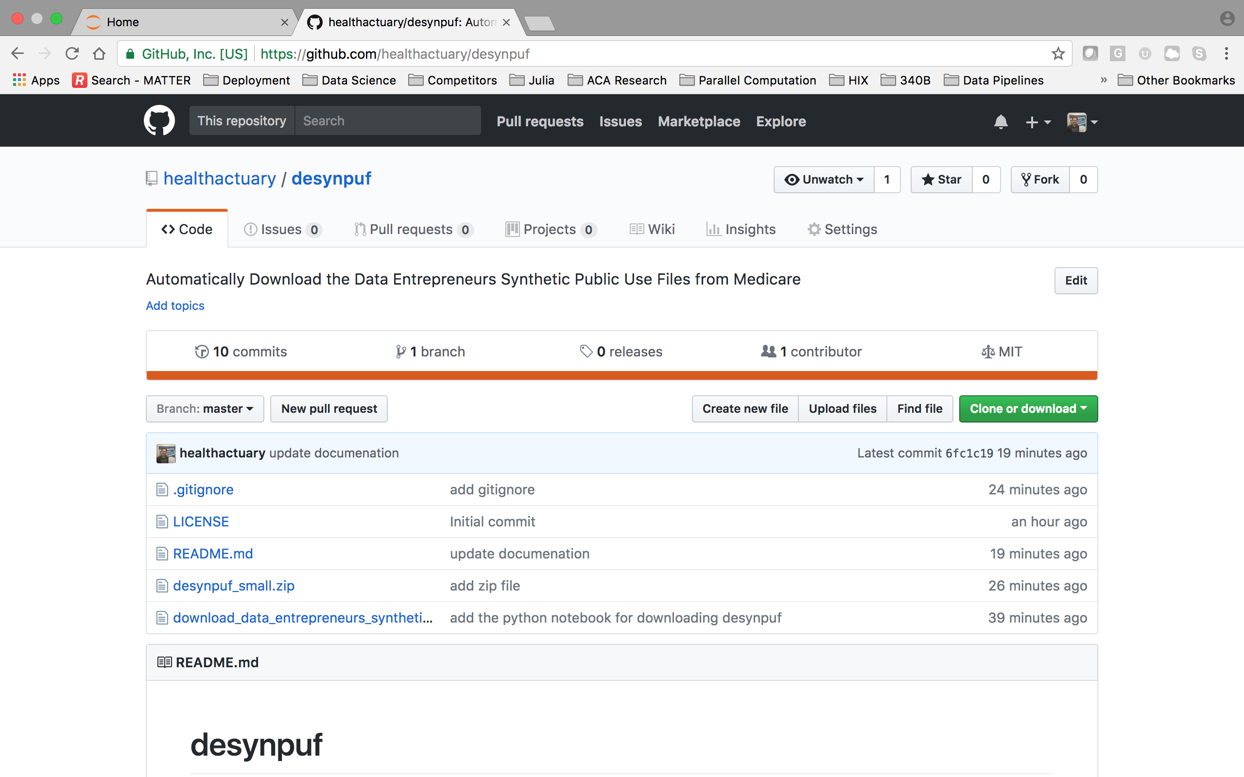Navigate to <https://github.com/healthactuary/desynpuf>
3. Select the desynpuf_small.zip link to download a zip archive containing the data files: <https://github.com/healthactuary/desynpuf/blob/master/desynpuf_small.zip>
4. Download the zip file and unzip its contents.
5. Verify that there are 60 Excel (.xlsx) files contained in the unzipped folder.
6. Copy the folder containing the 60 Excel files over to the current user’s root directory in Task I Step #4 on page 4 above.